“DIGITAL TRANSITION”

The training world is affected by epochal changes and challenges due to:
- New productive visions (ecological and energy transition, digital revolution, innovation of processes and technologies)
- New contexts (digital native’s trainees and trainers, changing of training contexts, boundless knowledge network flows, virtual reality, etc.).
- New organisational concepts (work organisation, logistics and spaces, distance working, reconfiguration of professions, etc.)
- New training configuration (training digital transformation, new products, new teaching methodologies, micro-training/individual training, etc.).

On these topics, debates and experiments involving companies, learners, educational institutions, research centres, are under development.

Serintel, which for over 20 years has been providing training for big companies in the energy sector, wants to be in tune with the times and contribute to the dissemination of digital culture and new applications on respecting of sustainability principles.

The following table, describes the conceptual outline of our “vision”

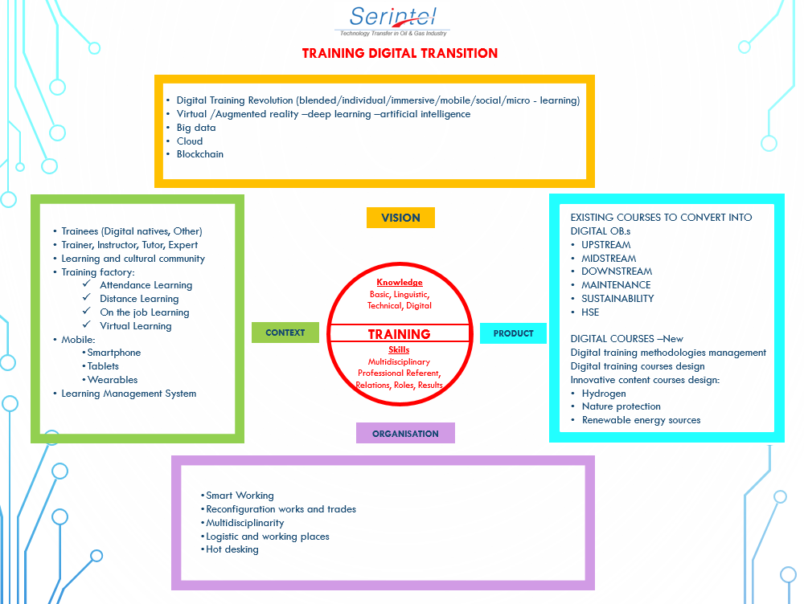

We will be happy to talk to all involved operators and institutions, students and companies interested to adapting their training to the changes taking place in the society of the 3rd millennium and to attribute value to the principles of sustainability.

Major companies in the world of industry and information technology are moving along these lines with ad hoc projects currently being implemented.

